Haunted Corn Maze
Sponsored By Tri-M Music Honor Society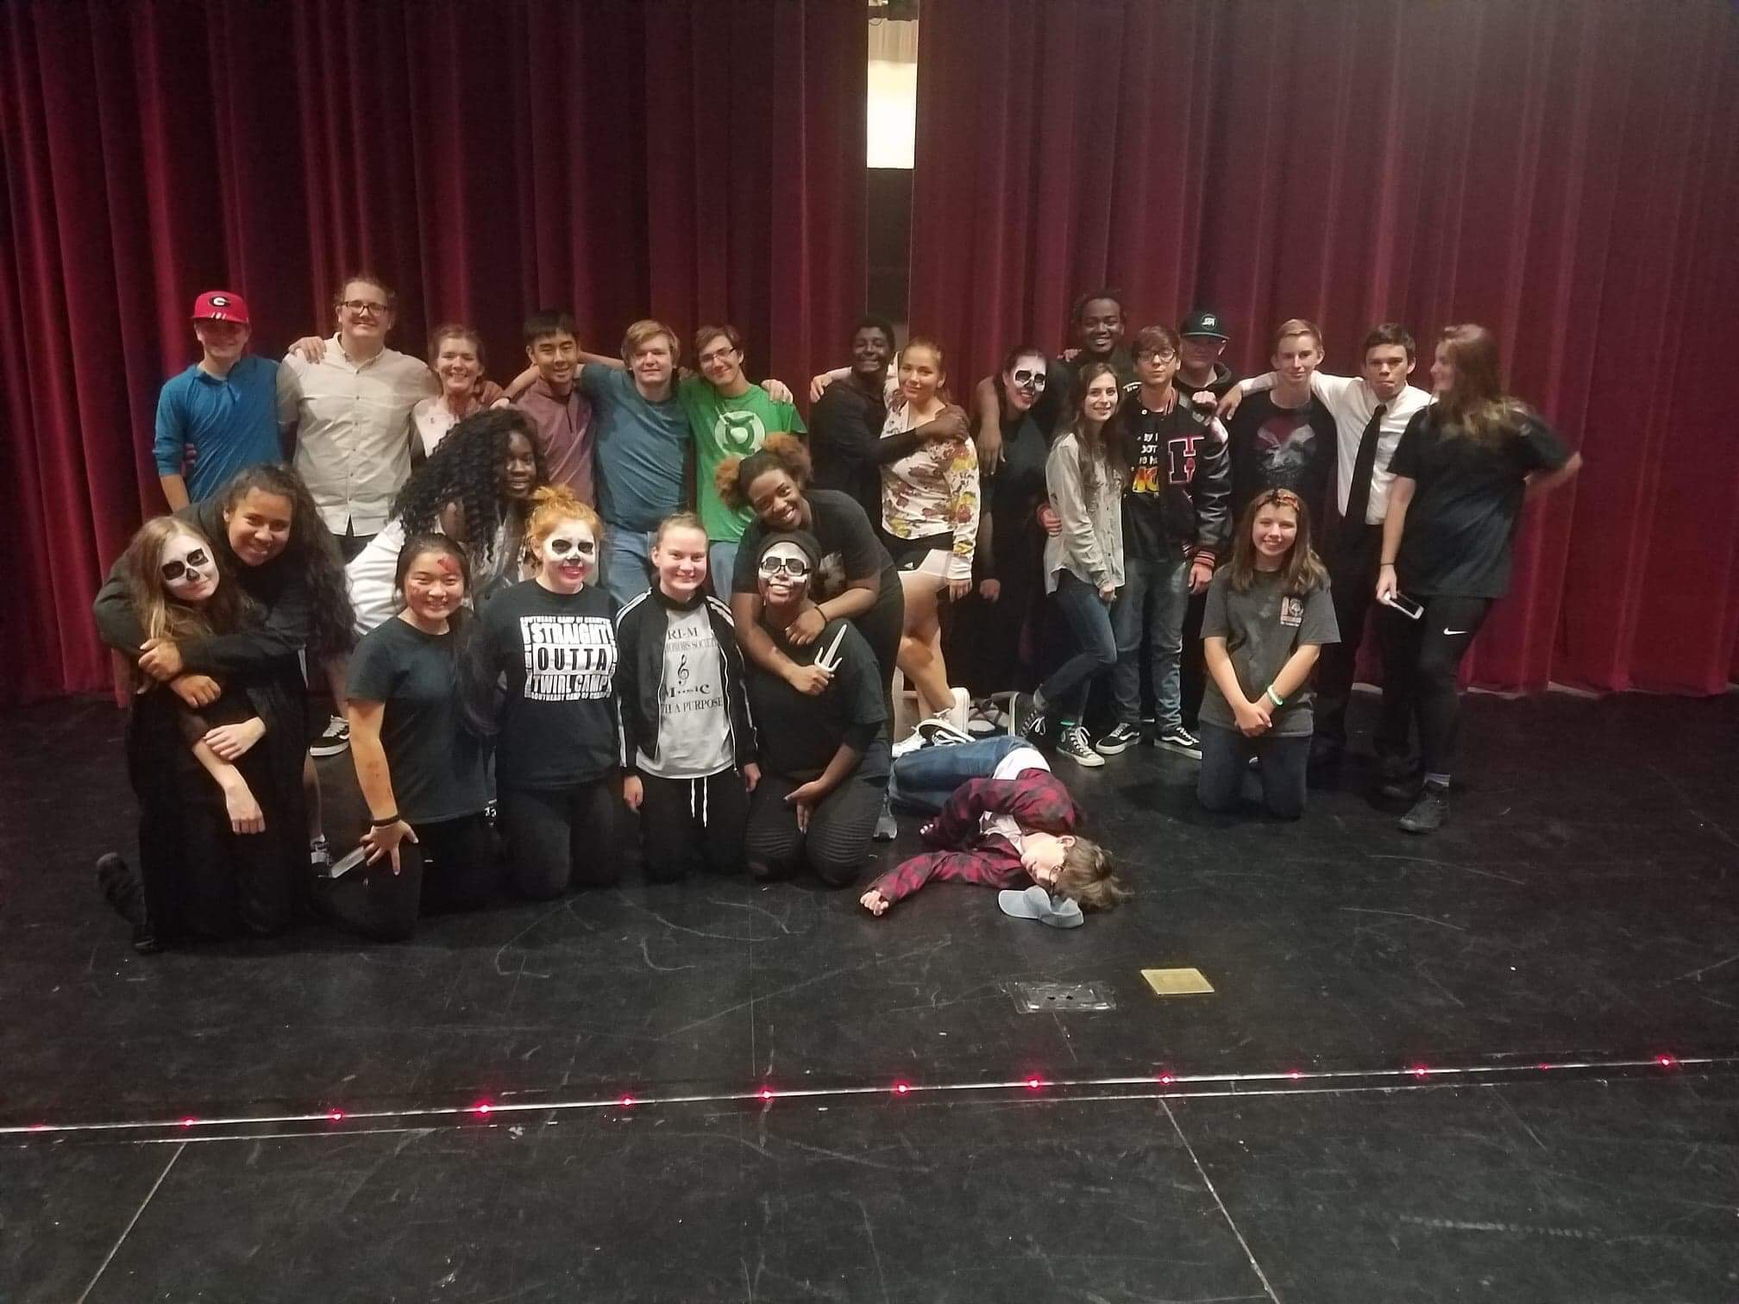
The Music Honor Society hosted the first ever Haunted House at HCHS. The event was a huge success, and all proceeds went to a former Hart County Fine Arts student battling sickness.
Stay tuned throughout the year to see other events by Tri-M and be sure to check in next year to see what the next scary thing will be at HCHS.
A big thanks to Addie Robison for bringing this idea to life.

